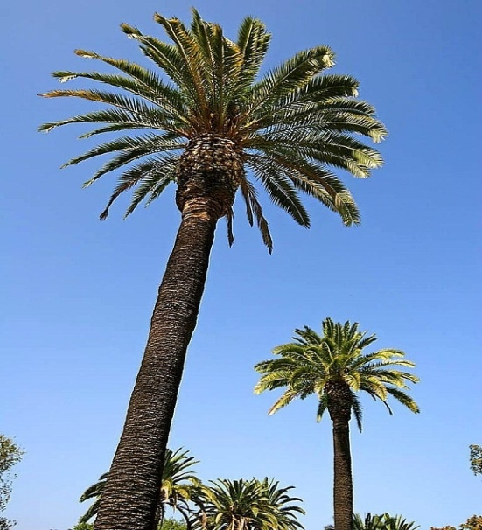
Fort Myers Rescue Mission
CAMP MEETING
Fort Myers, Florida

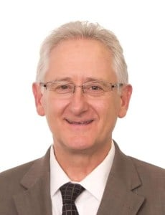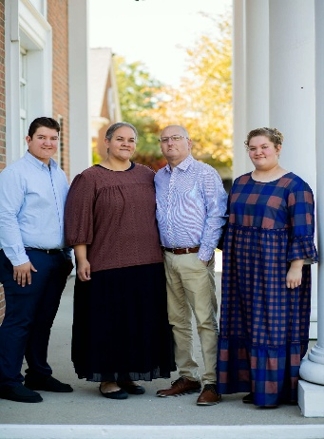
Dan Durkee Dan Hardy Mr. & Mrs. Mike Mayhle
Evangelist Bible Study Song Evangelist
---------------------------------------------------------------------------------------------------------------------
FEBRUARY 22 – 28, 2027 Daily Service times & Speaking Schedule
Mission Phone: 239-334-7365 Tuesday - Friday
Mission Address: 10 am Bible Study
6900 Mission Lane 1 pm Board Meeting (Friday only)
Fort Myers, FL 33916 7 pm Evening Service
Mission Lodging/RV parking: Saturday Sunday
Please call the office and schedule 10 am Mission Service 10 am Bible Study
(Monday Through Friday 9 am – 4 pm) 6:30 pm Latin American Ministries 11 am Morning Service
7 pm Evening Service 7 pm Evening Service

